Welcome to Chemistry in the Community.

Grading Policy
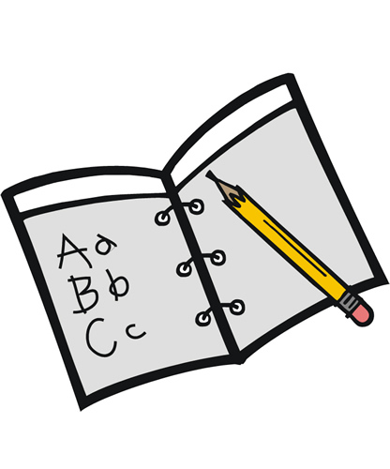
This class follows the OCHS pattern for grading.
90-100% A 80-89% B 70-79% C 69% and below is failing
- 70% of your grade comes from tests, 30% comes from daily work and activities. At the end, this will be 90% of your final grade, with the final exam being 10% of the rest. It is much easier to stay ahead and pass than it is to dig out of a non-passing grade. Therefore, plan to do well early on!
- Late work will be docked points. It will be graded at my convenience.
Supplies
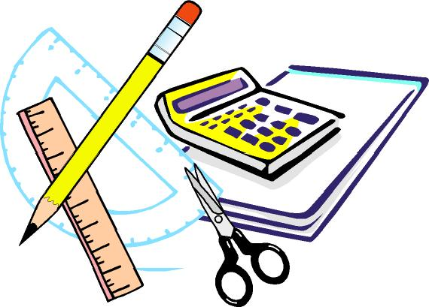
You will need to have a notebook, paper, and writing utensils with you every day.

Expectations
- You are expected to come to class with all of your supplies.
- You are expected to be on time and courteous.
- You are to follow directions, especially in the lab setting. Horseplay will result in disciplinary actions and point reductions.
- Work is to be handed in on time.
- Honor the learning environment-participate, interact appropriately.
Units of Study
- Scientific Argumentation
- Foundations of Matter
- Forces and Interactions
- Chemical Reactions and Mathematical relationships
- Thermochemistry
- Kinetics and Equilibrium

Communications
- 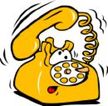
- Good communication is the key to being successful. Please ask early and often if you are having trouble with concepts or are concerned with your performance. I stay after school most days to give help; please let me know you are coming so that I can be in the room. My planning period is third if you need to speak privately with me. I prefer to contact parents using email, but I will also call if the situation warrants it. My email address is:
- Rebecca.Moehlmann@oldham.kyschools.us
- My phone number is: 502 222-9461 ext 115.
- Ms. Kohnke will also work with our fifth period class and Ms. Nethery will work with second.
Shalece.Kohnke@oldham.kyschools.us or Carrie.Nethery@oldham.kyschools.us
We look forward to getting to know each of you and working with you. Our goal is your success in this class, at school and in life. To that end, life lessons will also be shared! Do your best and do not be afraid to ask questions- this is how we learn.
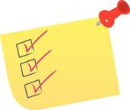Checklist
- There is a safety contract that you and a parent must sign. It must be returned to me before you can participate in any lab activities.
- Please have parent email me saying that he/she has read the syllabus. This also allows me to more easily communicate with them.
- On the safety form is permission to eat and drink foods in class that we work with from time to time. Make sure to fill that part out along with any allergies. (Nothing is too small to note.)
- Join Edmodo: code is ci9b3b I post daily what was done in class.
Mrs. Moehlmann

