Unit 2 Transfer Task – Cracking the Genetic Code!
BACKGROUND: Genetic screening has become possible thanks to new technologies as well as the completion and expansion of the Human Genome Project. Genetic screening is DNA testing that allows for the genetic diagnosis of diseases and disorders as well as provides a map of an individual’s ancestry and trait inheritance. Because this is a new and upcoming field in science, many scientists would like to be funded to continue their research efforts. However, getting funding is no easy task!

The Challenge: You will assume the role of a scientist researching a specific genetic disorder. You and your teammates are competing against other research groups for a grant to fund your ongoing studies as you search for treatment options.

The Task: A portion of this task will be completed individually and a portion of the task will be completed as a team. Below are the details of the task:

Step 1: TRANSCRIBE and TRANSLATE: You are going to utilize some of your existing technology to transcribe and translate a segment of DNA, deriving an amino acid sequence for the protein that this DNA codes for. (Document 1 - Independent)

Step 2: BLAST: You will now run your sequence through a computer program called BLAST to determine the exact protein that is affected.
(Document 2 - Independent)

Step 3: RESEARCH: After discovering the protein/gene that is mutated, you will compile research on your disease as well as cutting edge treatment options for your disease. (Document 3 - Group)

Step 4: PRESENTATION: Working together as a team of scientists, you will compile and communicate your research to a grant committee composed of physicians, fellow genetic researchers, pharmaceutical company executives and regular people from the general population. The grant committee will consist of a variety of individuals with different backgrounds. Please consider that you are trying to compile research that would be convincing all of the people on the committee; you might need to think from their perspective. (Group)

Presentation Details: Your presentation should be no longer than 8 minutes and can be done in any format you wish: PowerPoint, Prezi, Movie, Poster, Skit, etc. All members must contribute to both the creation and presenting of the presentation.

The Goal: Your goal is to get the grant committee to select your disease for full funding!!!

The Prize: The top 3 research teams to get selected by the panel will receive 5 extra credit points!!!

The Grade: This project is worth 100pts in the summative section of the gradebook. (see attached grading scale/rubric for more details)

Document #1 Name: ____________________________________
Procedure
- Obtain your DNA sequence from your teacher. Write your DNA sequence down in the space below indicated with a . Copy it down correctly!!

- Convert your DNA sequence into a complementary mRNA sequence.

Your DNA sequence:

mRNA sequence:

- Break your mRNA into codons. You can just put a line between each triplet base region on the mRNA sequence above.

- Translate the codon sequence into an amino sequence. Use the amino acid chart given in class. Record your sequence below:

Amino Acid Sequence:

____________________ ____________________ ____________________ ____________________ ____________________

____________________ ____________________ ____________________ ____________________ ____________________

____________________ ____________________ ____________________ ____________________ ____________________

Document #2 Name:______________________________________
- You will be using a computer program called DNA BLAST. It is an online catalogue of proteins that are created by specific genes a person has inherited. By back tracing the protein created we can tell what gene(s) the person has/doesn’t have. This has huge implications in medicine. In order to use this program you have to format your sequence of amino acids into a series of letters. These letters then get typed in the program in a later step. Use the amino acid chart below to write out the one-letter abbreviations for the amino acids in the sequence that you wrote on Document 1. (DO NOT simply write the first letter of the amino acid as its 1 letter abbreviation…USE THE CHART)

Amino Acid Code: ____ ____ ____ ____ ____ ____ ____ ____ ____ ____ ____ ____ ____ ____ ____
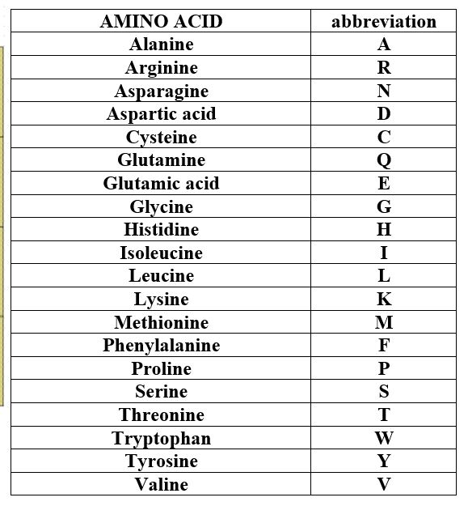
2. Go to http://www.ncbi.nlm.nih.gov/BLAST/ . Click on the NEW “SMART BLAST” button at the top of the page.
3. Enter the one-letter abbreviations for your amino acid sequence in the “enter accession number” box at the top – be sure to enter them in the correct order!
4. Click on the blue “BLAST” button.
5. In the Summary section at the top you will see a “Predicted Protein.” This is the protein that your DNA sequence codes for.
The protein your DNA sequence encodes is __________________________________
6. Click on your predicted protein and it will take you down the page a bit to some more information on that protein. If you click on the small blue word “gene” it will take you to information that you will need about the chromosome it is located on, the gene that houses that segment of DNA and the disease it is connected to. This is good information that will carry you forward in your research!!!

Teacher signature needed at this point to ensure you have done everything correctly before you being your research!
Teacher Signature: _______________________________________________

Document #3
Information will be included on your final product so this document does not need to be turned in.
- What causes this disorder? (protein, gene coding for protein, chromosome location)

- What is the normal function of this protein in body?

- What disease does it cause and what are the signs/symptoms?

- How does the mutated protein cause the symptoms? (be specific)

- What potential genetic treatments/therapies would you use your funding to research?

- Describe/discuss how your treatment would work to potentially “fix” the mutation causing your disorder.

