Create a Creature Graphic Organizer
Name: __________________________________________________________________________ Date:________________________________

Biome: ________________________________________________________________________________________________________________
3 traits necessary for survival in the biome
- ________________________________- Why? ________________________________________________________________________
- ________________________________- Why? ________________________________________________________________________
- ________________________________- Why? ________________________________________________________________________

Organism Name: ____________________________________________________________________________________________________
Energy source (producer, primary/secondary/tertiary consumer): _________________________________________________
Organism Adaptations:
Adaptation
Why?

Physiological
(at least 1)
Behavioral
(at least 1)
Structural
(at least 1)

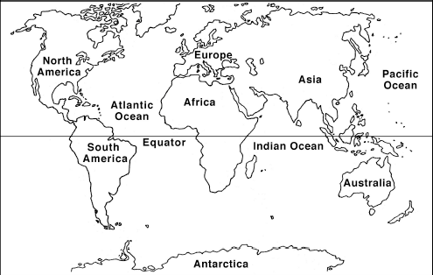
Location:

Sketch:

