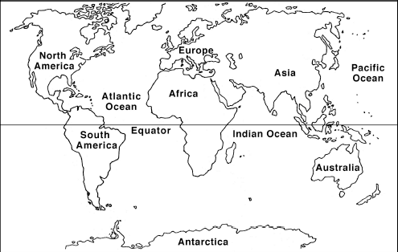

Weight:

Feature Creature

Biome:

Organism:

Diet:

Predators:

Behavioral Adaptations:

___________________________________________________________________________________________________________________

Why?____________________________________________________________________________________________

Snapshot:

Unique Characteristics:

______________________________________________________________________________________________________________________________________________________________________________________________________________________________________________________________________________

Physiological Adaptations

___________________________________________________________________________________________________________________

Why?_______________________________________________________________________________________________________________

Structural Adaptations:

___________________________________________________________________________________________________________________ Why?____________________________________________________________________________________________

Distribution:

Height: