Name ______________________________________ Date ______________________ Period_______

Unit 1 LT 2: Cell Cycle & Regulation Notes

BACKGROUND VOCABULARY

Chromosomes

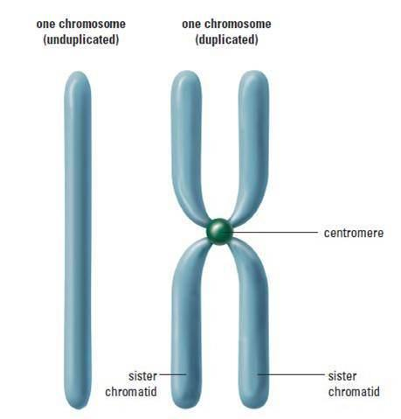
Chromatids

Centromere

Why Do Cells Divide? (3 reasons)
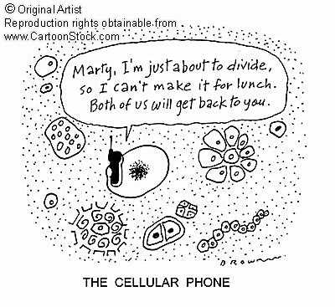

The Cell Cycle: What is it?

What Happens during the Cell Cycle?

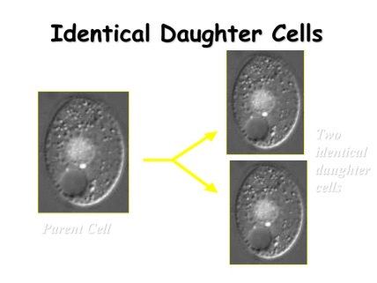
What is the goal/purpose of the Cell Cycle?

Two
Identical
Daughter cells

Parent Cell

4 Phases of the Cell Cycle
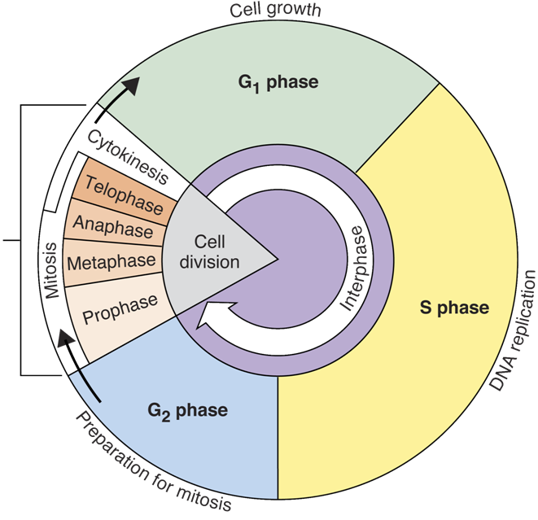
1.
2.
3.
4.
What happens during each of the 4 steps of the Cell Cycle?
- G -1 (Gap Phase 1) | - S - Synthesis
- G-2 (Gap Phase 2) | 4. M- phase

CELL CYCLE SUMMARY
Together, the G1, S, and G2 phases make up INTERPHASE.
What is interphase?

Cell Division
- Mitosis --
- Cytokinesis --
G₀
Mitosis: ( I ) – P – M – A—T
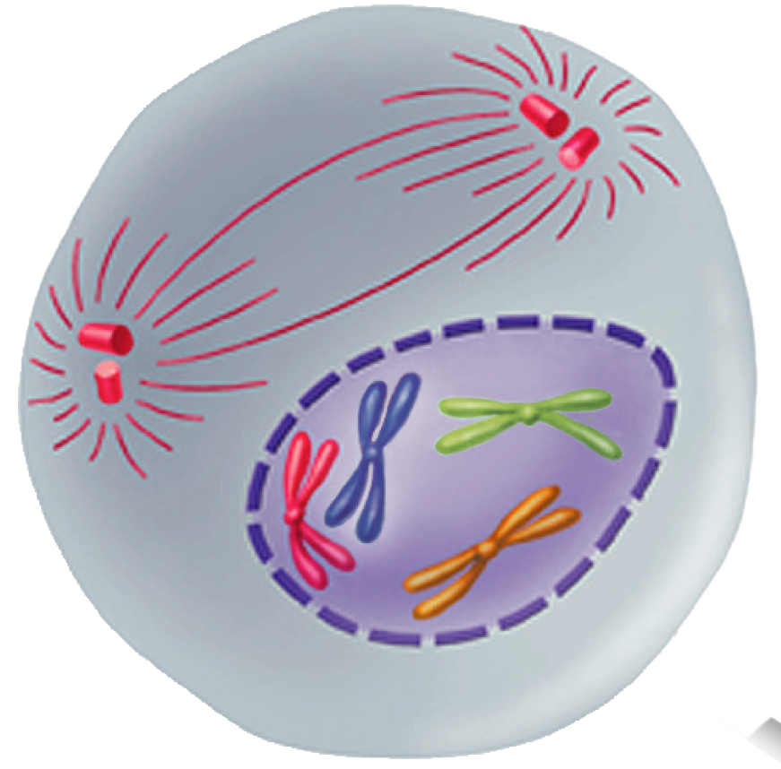
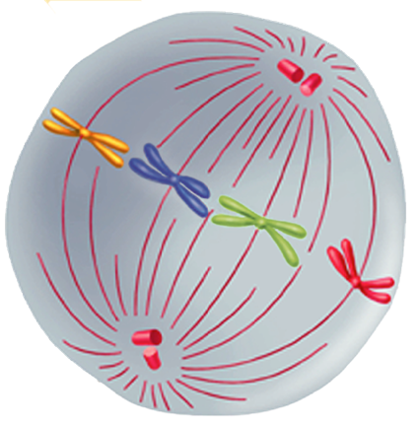
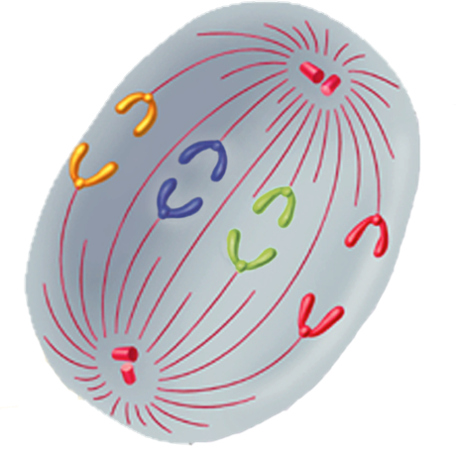
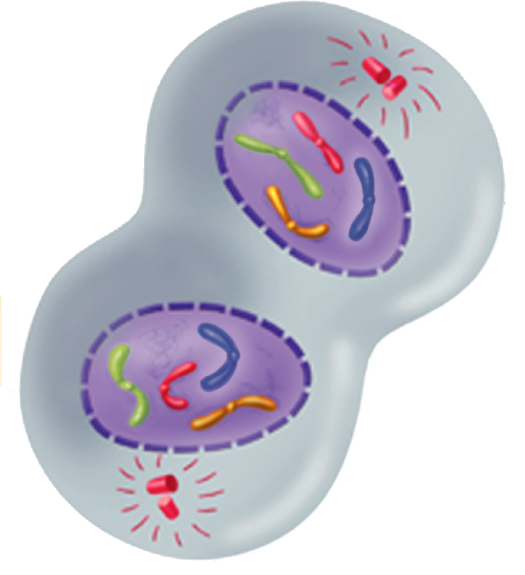

Cytokinesis in Animal Cells | Cytokinesis in Plant Cells
 | 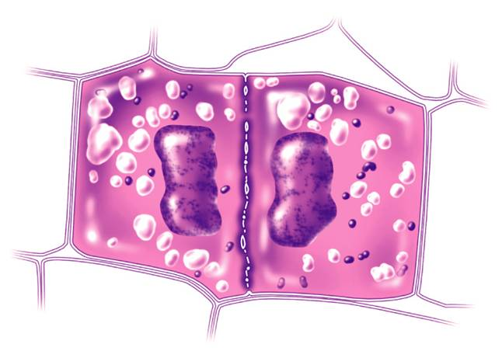

Cell Cycle Regulation
What does research say?

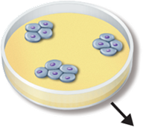 |  | 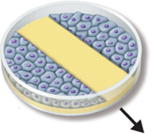 |  | 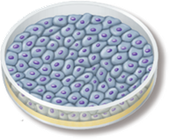
 | 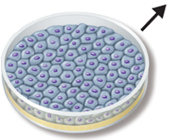 |  | 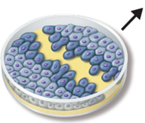

What are cyclins?

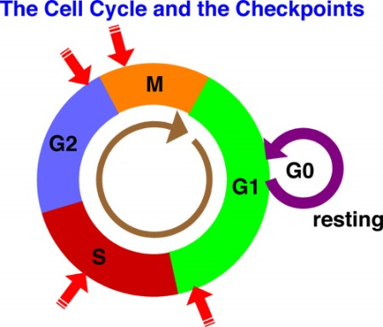
Internal Regulators External Regulators

CANCER

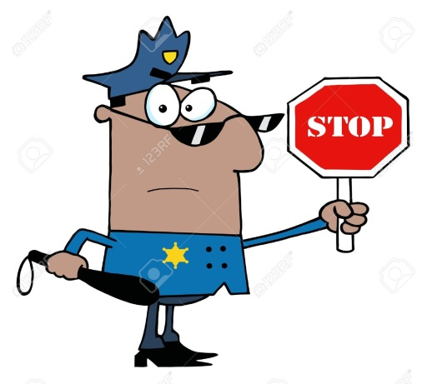

Problem Solving Activity

