World In The Balance: The People Paradox
PBS Nova Documentary

Geography
Locate and label each of these counties on the map above. They will be featured in this documentary.

India is a peninsula located in Southern Asia. It is centered at 22ºN and 77ºE.
Japan is an island country located off the East coast of Asia. It is centered at 36ºN and 138ºE.
Kenya is a country in sub-Saharan Africa. It is centered at 1ºN and 38ºE.

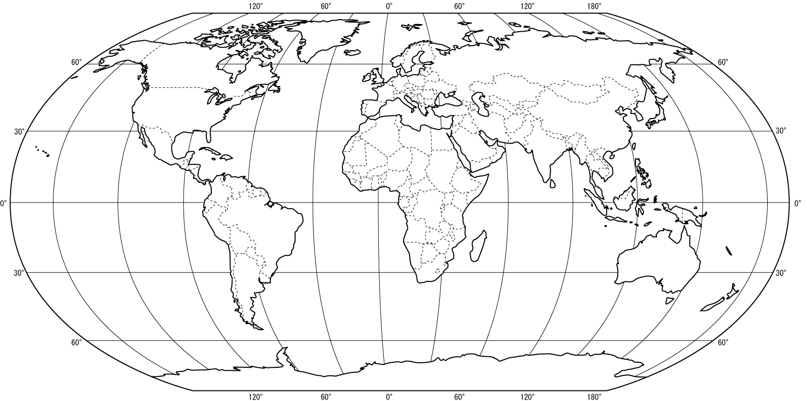

India
Answer questions 1-2 before watching the India segment.

- The population of India as of 2009 was about 1,155,000,000 (1.155 billion). What percent of the world’s population is this?

- The Gross Domestic Product of India in 2009 was $1,236,000,000,000 ($1.236 trillion). How much in dollars was produced per person?

- What is India’s current fertility rate overall?

- Uttar Pradesh is India’s fastest growing state. What is its fertility rate?

- One out of ten children in Uttar Pradesh dies before age five. How would this influence fertility rates?

- India is described as a “patriarchal” society. What does this mean?

- Describe how marriage is culturally different in India than in most developed countries.

- Teaching young adults about birth control is considered a social taboo in India. How would this influence fertility rates?

- Why are women seen as an “economic liability”? What is a dowry?

- Conducting an ultrasound with the intent to identify gender is now illegal in India. Why?

- Bride burning is a form of domestic violence in India where the bride is set ablaze when the husband and his family feel the dowry they were paid is not adequate. A newspaper article was written in response to this entitled “Better Dead than Burnt”. What does this title imply about gender equality in India?

- Abidi Shah is a social worker that works with women from poor, rural villages in India. In what two ways is she educating women?

- If India is unable to reduce its population growth rate, what possible consequences might it face? Describe two.
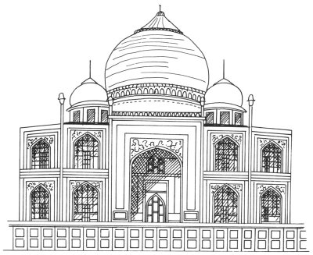

- The Taj Mahal is a palace that was built to honor a queen who died giving birth to her 14th child. How is this symbolic of the struggles that India faces?

- Below is a breakdown of the population of India as of 2009. Construct a population pyramid.

Age Group | M | % | F | %
0-4 | 62,926 |  | 55,735 | 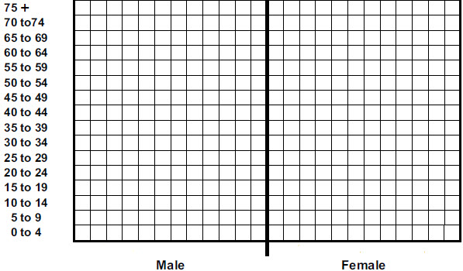
5-9 | 62,691 |  | 55,188
10-14 | 61,581 |  | 54,363
15-19 | 57,793 |  | 51,608
20-24 | 53,986 |  | 49,403
25-29 | 50,581 |  | 46,847
30-34 | 46,925 |  | 43,940
35-39 | 42,961 |  | 40,800
40-44 | 37,059 |  | 35,382
45-49 | 31,298 |  | 29,991
50-54 | 26,031 |  | 25,056
55-59 | 21,033 |  | 20,417
60-64 | 16,466 |  | 16,353
65-69 | 12,312 |  | 12,674
70-74 | 8,408 |  | 9,105
75+ | 4,950 |  | 5,727
Total | 1,156,897 (in thousands)

Data from US Census Bureau

What does the shape of this pyramid tell you about India’s demographics? What patterns or trends do you see?

Japan Analysis Questions
Answer questions 16-17 before watching the Japan segment.

- The population of Japan as of 2009 was about 127,000,000 (127 million).
What percent of the world’s population is this?

- The Gross Domestic Product of Japan in 2009 was $5,286,000,000,000 ($5.286 trillion).
How much in dollars was produced per person?

- What is the fertility rate of Japan? How does this compare to India?

- Tomoko Omura states that there are two doors for professional women. What choice is she alluding to?

- How would you describe the attitude the Japanese women have towards marriage and children?

- How does Japan’s economic recession affect the roles of women and birth rates?

- What are the consequences if there are not enough young, working people to support a retired population?

- How many immigrants would Japan need to allow into the country a year to maintain its workforce? Why does it resist this type of immigration?

- The beginning of this segment showed a fifth grade student sitting in a classroom by himself – the only student in his entire grade. How is this scene reflective of Japan’s demographic situation?

- Below is a breakdown of the population of Japan as of 2009. Construct a population pyramid.

Age Group | M | % | F | %
0-4 | 2,675 |  | 2,534
5-9 | 3,022 |  | 2,864
10-14 | 3,107 |  | 2,946
15-19 | 3,126 |  | 2,969
20-24 | 3,460 |  | 3,300
25-29 | 3,899 |  | 3,730
30-34 | 4,547 |  | 4,352
35-39 | 5,033 |  | 4,839
40-44 | 4,308 |  | 4,218
45-49 | 3,884 |  | 3,848
50-54 | 3,847 |  | 3,858
55-59 | 4,575 |  | 4,687
60-64 | 4,508 |  | 4,733
65-69 | 3,869 |  | 4,278
70-74 | 3,096 |  | 3,665
75+ | 2,443 |  | 3,236
Total | 127,079 (in thousands)
Source: US Census Bureau

What does the shape of this pyramid tell you about Japan’s demographics? What patterns or trends do you see?
United States

- The amount of consumption and pollution from an average American child is equal to how many children from India?

- The United States, like Japan, is experiencing an increasing number of aging people in the population. What is the main difference between the two? How does this benefit the United States?

Sub-Saharan Africa

- How much has Kenya’s fertility rate changed in the last 20 years?

- What has caused death rates to increase in Kenya, as well as life expectancy to drop to 49 years?

- One of the experts states that the root of Africa’s struggles with population, poverty, and AIDS is unprotected sex. If this is the case, why is birth control and protection not more widely used?

- There are two predictions given for final world population.

  - What is the predicted final population if fertility rate drops just below 2 children per couple?

  - What is the predicted final population if fertility rate is 0.5 children per couple higher?

- A demographic transition graph is shown below. Mark on the graph where you would place Kenya, Japan, the United States, and India, based on what you learned from the video.

